Appendix A
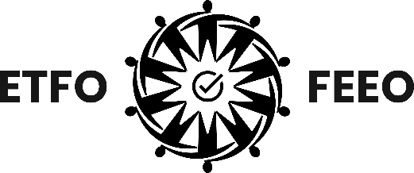
Elementary Teachers’ Federation of Ontario (ETFO)
Fédération des enseignantes et des enseignants
de l’élémentaire de l’Ontario (FEEO)
136 Isabella Street, Toronto, ON M4Y 0B5
Tel: 416-962-3836 Toll Free: 1-888-838-3836 etfo.ca

APPLICATION FORM
OTF INTERNATIONAL ASSISTANCE COMMITTEE
Name:
E-Mail:
ETFO ID Number:
Name of Local:
Home Address:
City:
Postal Code:
Home Phone:
Name of Workplace:
Fluent Language(s) Spoken:
Current Assignment:

Indicate why you have chosen to apply for the OTF International Assistance Committee:

Indicate the skills you possess that would be relevant to the committee:

Indicate your previous involvement with similar organizations:

Highlight any personal involvement you have with your local federation:

Highlight any personal involvement you have with your provincial federation:

OTF INTERNATIONAL ASSISTANCE COMMITTEE

Role of the members on OTF’s International Assistance Committee:

- The Committee meets twice a year to consider grant applications received from approximately 22 developing countries;

- OTF receives between 400 and 500 applications for funding each year. The applications are summarized by OTF staff and funding decisions are taken jointly by the four committee members – one from each Affiliate;

- In general, Committee members have lived, worked, or travelled extensively in developing countries, and bring this experience to their decision making;

- Committee members also serve as trustees to the Blanche Snell Estate Fund and the Ontario-Lesotho Educational Sustaining Fund;

- While priority areas may change from year to year, in general the Committee has given priority to projects benefitting girls and women, school sanitation and water purification projects, funding for students with special needs, school repairs and rebuilding, teacher education and the basic educational needs of impoverished and at-risk students;

- While not a requirement for service on the committee, most members remain on the committee for several years.

Self-Identification

Member self-identification allows ETFO to achieve a critical goal, supporting and encouraging the participation of all members in ETFO programs, services and events. By completing this section, ETFO will be able to undertake the necessary statistical analysis to achieve this goal. All information collected and the reporting of statistical data will ensure full confidentiality of all members. Although the completion of this section is voluntary, ETFO encourages members to self-identify.

First Nations Métis Inuit Person with a Disability Woman 2SLGBTQ+

Racialized If you identify as racialized, please provide additional details: _______________________________

Please return the completed form to
David Mastin at dmastin@etfo.org
by
Friday, September 12, 2025 at 5:00 p.m.

